
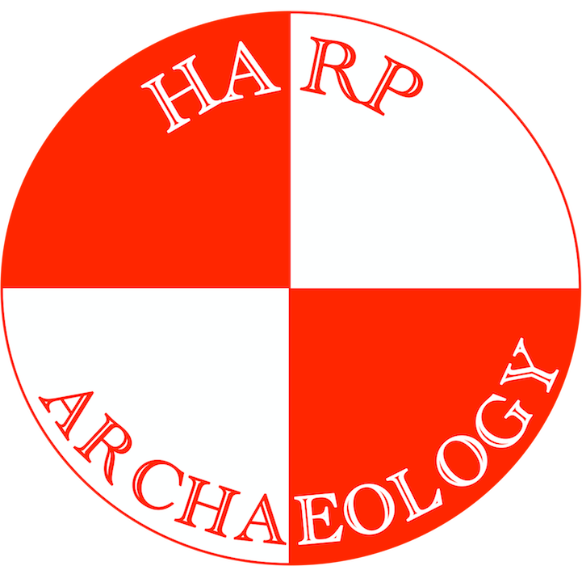

Please return via email ian@harparchaeology.co.uk

Bedrule Castle: Excavation Field School Application Form
8th to 20th August 2026

Name:
Address:
Email:
Age Group: | 17-29: | 30-49: | 50-64: | 65+:
Gender**:
Nationality:

Application Type (delete as appropriate): | Student  (With accommodation)  £1,095 | Student  (No accommodation)  £645 | Non-Student  (With accommodation)  £1,195 | Non-Student  (No accommodation)  £745

*Please delete options as appropriate
Please give a brief description of the reasons for your interest in participating in this field school, what you would like to get out of it, and what you might be able to contribute to the project:
Please give brief details of any previous archaeological or other relevant experience or training, including university courses:
Do you have any dietary requirements? (For instance vegetarian, vegan, halal) ^ | Yes/no*
If yes please provide details:
Do you have any allergies? ^ | Yes/no*
If yes please provide details:
Do you suffer from any medical conditions or are you on any medication that may affect you during the course? ^ | Yes/no*
If yes please provide details+:
Do you want to complete a training manual during the course? (£40 fee) | Yes/No*
Where did you hear about the course?:
Please indicate how you intend to pay: | Stripe* | Bank Transfer*

Please Note:

Payments from outside the UK will need to be completed via Stripe and can be made using a debit or credit card, or via Apple Pay or Google Pay. All payments via Stripe will be subject to a processing/handling fee.

A non-refundable 25% deposit is required within two weeks of being offered a place on the field school in order to secure it.

It is essential that you have an up to date Tetanus vaccination.

** Gender is requested to help room allocation and accommodation setup.

^ Dietary requirements, allergies and medical conditions are requested in order to allow us to be able to facilitate everything in as safe and inclusive an environment as possible. All information will be kept strictly confidential and will not be used to exclude people from participation.

Full terms and conditions for HARP field schools can be found at https://www.harparchaeology.co.uk/field-schools/field-school-terms-and-conditions.

