Field School for Quaternary Palaeoanthropology and Prehistory of Murcia, S.E. Spain, 31st Field Season 2020
Murcian Association for the Study of Palaeoanthropology and the Quaternary, MUPANTQUAT, http://www.mupantquat.com
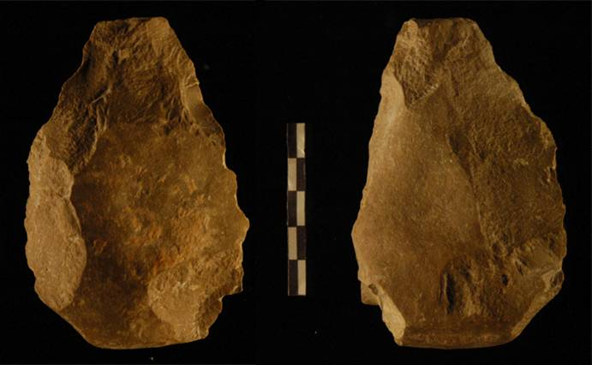  Cueva Negra hand-axe | Session 1: June 29th–July 20th 2020 at Cueva Negra del Estrecho del Río Quípar  Session 2: July 20th – August 10th 2020 at Sima de las Palomas del Cabezo Gordo  Coordinated and directed by  Dr. Michael Walker, DPhil, BM, BCh, MA, DiplPreArch (Oxon), FSA, FSAScot, FRAI,  Chair of MUPANTQUAT; archaeologist and physical anthropologist, Hon.Emeritus Professor, Murcia University Biology Faculty, mjwalke@gmail.com, walker@um.es (+34-620267104);  Dr María Haber Uriarte, archaeologist, Murcia University Dept. of Prehistory & Archaeology, Vice-Chair of MUPANTQUAT, mariahaber@um.es;  and archaeologist Mariano López Martínez, Hon.Sec.of MUPANTQUAT, marianolopez@hotmail.com, info@mupantquat.com |  | 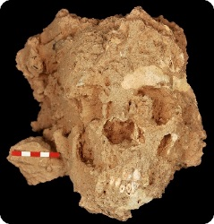  Sima de las Palomas Neanderthal child skull
Excavation has been ongoing for 30 years at both sites. Cueva Negra has abundant evidence of fire, a final Early (i.e. Lower) Pleistocene fauna, an “Acheulian” hand-axe, numerous flake-tools, and extinct fauna in sediments laid down between 772,000 and 990,000 years ago (probably during the interglacial period from 868,000 to 814,000 years ago), according to biostratigraphy, palaeomagnetism, and geophysical dating. Sima de las Palomas has >300 skeletal parts (teeth, bones) of 15 Neanderthal individuals, including 3 articulated skeletons one of which is 85% complete 55,000-50,000 years ago, an early Late (i.e. Upper) Pleistocene fauna, and Mousterian Palaeolithic artifacts, dated by ¹⁴C, U-ser, OSL and ESR, with new finds of Neanderthals teeth and mandible, fauna, and Mousterian artifacts in deep layers dated to 130,000-90,000 years ago.

We invite applicants to take part in our 2020 summer field season. All applicants are considered sympathetically; prior archaeological experience is less important than keenness. To apply, just send an email with brief cv after going to our MUPANTQUAT web-page, clicking there on FIELD SCHOOL and then on “BRIEFING YOU” (there’s no application form to fill in as we keep paperwork to a minimum). The Murcian Association for the Study of Palaeoanthropology and the Quaternary (MUPANTQUAT) coordinates the Field School and excavations, issues your Certificate of Attendance, and makes you a member for the current year (we also sign forms you bring from your university).

While at Cueva Negra (Session 1) we stay at the residential Ascruz school (which has its own kitchen staff) at Caravaca de la Cruz. While at Sima de las Palomas (Session 2) we put bunks in the public school at Dolores de Pacheco and take our meals in the restaurant of the village civic centre nearby. Both schools have showers, cleaning staff, and concierges. We organise laundry at both places. Both schools give us some access (often erratic, alas) to wifi and internet. We can use the municipal public swimming pools at Caravaca and Dolores (which is also near the beach). At both places, you must bring sheets, pillow-slip, towel, soap and shower-gel. Summer is hot in Murcia: you'll get a chance to swim. Bring light work clothes and flat-soled light footwear for Cueva Negra but bring work boots for Sima de las Palomas. Bring sun-hats, sun-glasses, sun-cream, swimmers. If you've a driver’s licence, please bring it. Your contribution includes all meals and laundry.

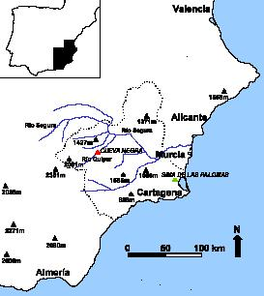
We cannot meet or set down helpers on any other dates than the start and finish dates of each session. On those, we meet our helpers at Murcia Corvera International Airport on the first day of each session and set them down on the last. Budget airlines fly to it from the UK and other countries. For Sima de las Palomas we can meet helpers at the Balsicas-Mar Menor railway station where all trains stop that go to Cartagena from Madrid or Barcelona. It is less easy for us to meet helpers for Cueva Negra who want to arrive by train; we prefer to meet at Cieza railway station those who board at Madrid (not all trains from Madrid to Murcia and Cartagena do stop at Cieza, so helpers should check which ones do). Trains from Madrid and Barcelona stop at Murcia city where, however, we are extremely reluctant to try to meet helpers because passengers flooding off the trains can result in missed encounters, for which reason also we refuse to meet helpers at Alicante International Airport (where, moreover, flights are often delayed), so helpers for Session 1 arriving at those destinations should take buses to Murcia city bus station and there take another bus to Caravaca bus station where we can meet them, provided they phone us to tell us when they expect to arrive there. If helpers for Session 2 choose to land at Alicante International Airport they should try either to take a bus directly to San Javier (there is one from Alicante bus station to Cartagena, though that means first getting to the bus station from the airport), or the bus from Alicante Airport to Murcia city bus station and then the bus service from there to San Javier or the different service to Torre Pacheco; we may be able to meet them at either town provided that they phone us to tell us when they expect to arrive there. Tickets are sold at Alicante Airport for the direct coach service from it to Murcia city bus station. In 2019 there was a coach from Madrid Barajas Airport to Cartagena that stopped at Torre Pacheco, of possible interest for Session 2 should it run again in 2020 (anyone taking it should phone us advising us when they will arrive at Torre Pacheco bus station so we can meet them). There are NO buses from Madrid or Barcelona to Caravaca, so bus travellers from those cities for Session 1 will have to take buses first to Murcia city bus station, and there take another bus to Caravaca bus station (it leaves every hour from 06.10 h to 21.20 h on weekdays) where we could meet them provided that they phone to say when they expect to arrive there.

Your contribution of 50€ (euros) per day for a complete 21-day session (1,050€ altogether) includes board, meals, instruction, local travel from pick-up point and back, daily travel between our base and site, official excursions, and your registration as a MUPANTQUAT member for the year 2020. If you come for two complete sessions your contribution is reduced to 45€ per day (1,890€ altogether). If you come for less than a complete session your contribution is 60€ per day. All former participants contribute at 45€ per day for whatever length of stay. On a case-by-case basis, and provided it does not produce numerical imbalance of helpers within a session, consideration may be given to allowing youngsters, who can justify impecunious circumstances and are first-time participants, to take part for 45€ per day (450€ altogether) during a 10-day period corresponding either to the first or the second half of either session 1 or session 2 (though such participation implies they will miss half of the 20-day programme of the session). All participants must pay for their own air/rail/coach fares to our pick–up/set-down points and for their personal expenses.

Daily routine: we rise at 7 a.m. and after a light breakfast we excavate from 8 a.m. till 2 p.m. with a mid-morning sandwich. A cooked lunch at 3 p.m. is followed by a nap. We sort finds from 5 p.m. till 9 p.m. when we have a hot dinner. In each 3-week period, there are talks and seminars about our work and human evolution, and we also visit local places of interest. The programme is thus based on a 3-week Session (if you stay for a shorter time you'll miss part of the programme). The normal contribution from helpers staying for a full Session corresponds to €50 euros (€50) a day; covering instruction, board, lodging, and local transportation, or €45 a day when both full sessions are attended (first-time participants staying for less than one full session should contribute €60 a day). To guarantee a place you must send a non-returnable deposit, preferably by May 1st 2020, of €250 (euros) per each 7 days of intended stay. You pay the balance on arrival. You must arrange your own health and personal accident insurance cover beforehand, holiday/travel insurance if desired, and sign an indemnity form on arrival. EU residents should bring the EU card from their country entitling them to public health care in other EU Member States.

Cueva Negra del Estrecho del Río Quípar
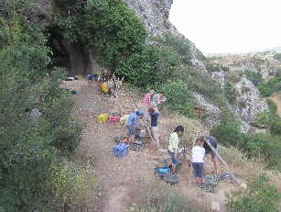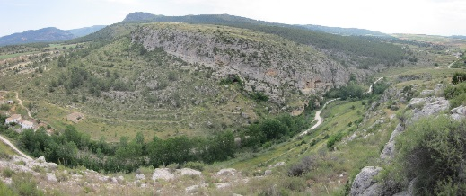
Cabezo Gordo and Sima de las Palomas 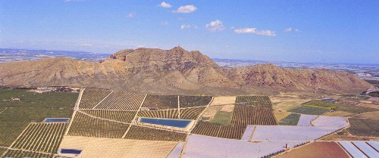 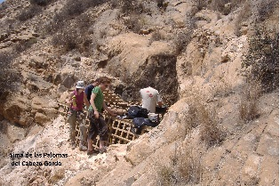

Field School for Quaternary Palaeoanthroplogy and Prehistory of Murcia, S.E. Spain.
BASIC INFORMATION
Organization:: Murcian Association for the Study of Palaeoanthropology and the Quaternary, MUPANTQUAT
Session 1: Mon June 29 – Mon July 20, 2020, at Cueva Negra del Estrecho del Río Quípar (Caravaca de la Cruz, Murcia, Spain).
Session 2: Mon July 20 – Mon August 10, 2020, at Sima de las Palomas del Cabezo Gordo (Torre Pacheco, Murcia, Spain).
Contact: Hon. Emeritus Professor Michael J. Walker, Murcia Universiyt, Biology Faculty; Chair MUPANTQUAT
Emails mjwalke@gmail.com; info@mupantquat.com
Further information : http://www.mupantquat.com
Description | Excavation and instruction at Pleistocene Palaeolithic sites with hominid remains:  Cueva Negra: final Early (i.e. Lower) Pleistocene (900-800,000 years ago); with evidence of fire, abundant Palaeolithic artifacts (including a hand-axe), and a rich palaeontological assemblage.  Sima de las Palomas: early Late (i.e. Upper) Pleistocene (130,000-40,000 years ago), with abundant Homo neanderthalensis skeletal remains, Mousterian Palaeolithic artefacts and abundant faunal remains.
Periods | Session 1, June 29 – July 20, 2020; Session 2, July 20 – August 10, 2020.
Country | Spain
Locality | Session 1: Cueva Negra del Estrecho del Río Quípar (Caravaca, Murcia, Spain);  Session 2: Sima de las Palomas del Cabezo Gordo (Torre Pacheco, Murcia, Spain)
Travel | June 29, July 20, August 12: On these dates participants are picked up/set down by our staff at Murcia Corvera International Airport or at the railway stations of Cieza (Session 1) or Balsicas-Mar Menor (Session 2). We ask Session 1 helpers to try to book flights that land at Murcia Corvera Airport before 7 pm and depart after 10 am. Participants wishing to make alternative travel arrangements should consult us beforehand, though it may not be possible to meet you and you may have to make your own way to our bases.
Duration | Two 3-week sessions. In order to get the most out of their stay we strongly recommend participants come for one full session at least.
Age | Minimum 18 years
Qualifications | Previous experience is not essential though preference is given to undergraduates and graduates in appropriate subject areas.
Work | All participants take part in excavation and cleaning and sorting finds, and will receive both practical instruction and talks about our research and about human evolution and Palaeolithic archaeology in the Pleistocene.
Language | English (any knowledge of Spanish is also useful).
Accom. | Bunks in schools with showers etc. Light breakfast, mid-morning sandwich, cooked lunch, cooked evening meal. Vegan, halal, and kosher menus are NOT available. Bring your own sheets and towel.
Contribution | FOR A COMPLETE SESSION: 50 euros per day includes bed, meals, instruction, local travel from pick-up and back, daily travel between our base and site, official excursions. You must pay for your own travel to the pick-up points and personal expenses. FOR TWO COMPLETE SESSIONS: 45 euros per day. FOR LESS THAN 21 days: 60 euros per day. Former helpers who return: 45 euros per day. On a case-by-case basis, and provided it does produce numerical imbalance of helpers within a session, consideration may be given to allowing youngsters, who can justify impecunious circumstances and are first-time participants, to take part for 450 euros during a 10-day period (45 euros per day) corresponding either to the first or the second half of either session 1 or session 2 (though such participation implies they will miss half of the 20-day programme of the session).
Application | There is no application form: just send an email to mjwalke@gmail.com and you MUST attach a 1-page (brief) c.v. as a simple WORD document without inserts or special features, which MUST include (1) your full name, (2) date of birth, (3) nationality and passport number, (4) permanent home address, (5) address for correspondence, (6) contact phone number(s) and email address(es). Until we have received all 6 pieces of information, we do not respond to an enquiry.  Visit our web-site http://mupantquat.com, save or print out a long download called BRIEFING YOU and read it carefully.  A non-returnable deposit in advance is required of 250 euros per 7 days of intended stay, with balance payable on arrival. Preference is given to applicants wishing to stay for a full 3-week session whose deposits are received before May 1st 2020.
Notes | Each session includes one full-day excursion to other nearby sites of archaeological interest.  At both sites set meals are provided only (so as to keep costs down). Strict halal, kosher, and vegan menus cannot be prepared, though salads, fruit, and eggs are always available. Participants with particular medical conditions involving specific intolerance (e.g., to gluten, lactose, shell-fish, etc.) should inform us so that our kitchen staff can make due provision.  We issue attendance certificates with number of hours of practical experience and instruction. (Although US college credit is NOT available from us, undergrad US college students often can arrange beforehand with their faculty professors to gain credit for participation by presenting papers about it on return home and we are willing to assist in orientating them during their period on site.)  We regard all of you as field helpers and in 2020 your contribution will include automatic 2020 membership of MUPANTQUAT.

