I am so grateful for the Archaeological Institute of America’s Waldbaum Scholarship. It helped enable me to travel to and from Red Cliff, Wisconsin, help partially cover tuition cost, and supplemented me for general miscellaneous expenses like laundry during my experience with the Geté Anishinaabe Izhichigéwin Community Archaeology Project (GAICAP) - Archaeological Field School.
GAICAP is a collaboration of the Red Cliff Band of Lake Superior Chippewa and North Dakota State University, directed by the Red Cliff Tribe of Lake Superior Chippewa’s Tribal Historic Preservation Office (THPO) and archaeologists at North Dakota State University and the University of Wisconsin-La Crosse. We focused on excavation and survey at two sites. One is an undisturbed pre-contact site located in Frog Bay Tribal National Park where we investigated geté Anishinaabe izhichigéwin (Anishinaabemowin for “ancient Indigenous lifeways”). Our other site used survey methods to identify the location of historic sites associated with an Indian Pageant from the 1920’s. However, in addition to survey, excavation, and curation skills, GAICAP focuses on community engagement and service learning. We volunteered and participated in the annual Red Cliff powwow and summer language camp.
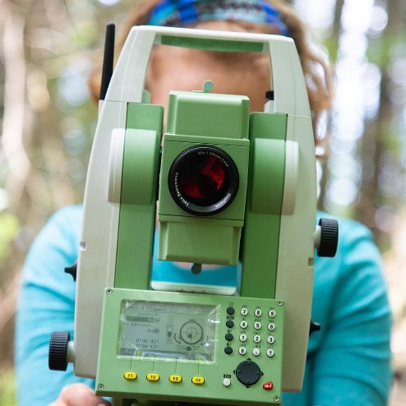
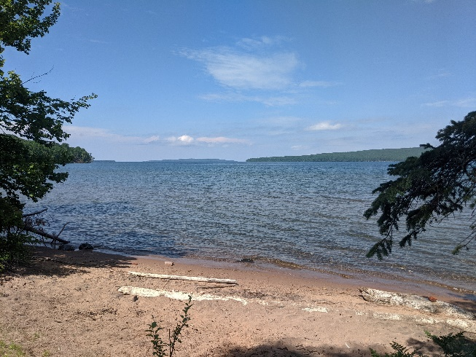
I cannot express just how much I learned and grew through this experience. It taught me valuable skills and changed how I see the world. I could see myself improve in my archaeology day-to-day. And I could tell how my worldview grew by interacting with so many different people. I take the stories and lessons with me every day and am so grateful for everyone who made my experience what it was!
1: A photograph of me levelling a total station. Picture taken by Tyrel Iron-Eyes.
2: A picture from Frog Bay Tribal National Park where one of our sites were.

