Annalisa Amber Field School Report
In my first year of graduate school for archaeology, I found myself eager to gain hands-on experience and learn the essential tools and techniques crucial for a successful archaeologist. Thanks to the generous support of the Jane C. Waldbaum Archaeological Field School Scholarship provided, I had the incredible opportunity to participate in a field school, where I could acquire the practical skills and knowledge necessary to excel in the field of archaeology. This scholarship not only opened doors to a world of archaeological exploration but also marked a significant milestone in my educational journey, allowing me to bridge the gap between academic theory and real-world application, and ultimately shaping me into a more capable and well-rounded archaeologist.

Spring of 2023 I participated in a field school located in Tazewell County near Lowpoint, Illinois. The site was called the Ten Mile Creek site. It was a Late Mississippian site (AD 1200-1400) located in the ancestral homelands of the Peoria tribe.

This fieldwork opportunity was organized in collaboration with archaeologists from the University of California-Santa Barbara, Indiana University, and Dickson Mounds Museum. In this program, I learned a series of great tools like excavation, mapping, artifact-processing techniques, and even geo-mapping techniques. I excavated six days a week (Monday through Saturday) in hot to fair conditions. The funds graciously provided by were used to pay for the field school fees and a small portion was used to purchase field school equipment.
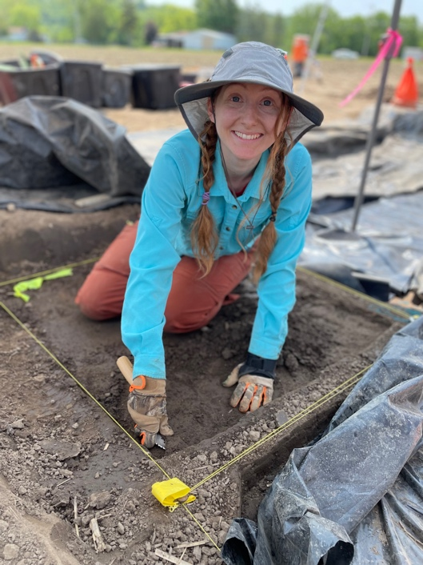
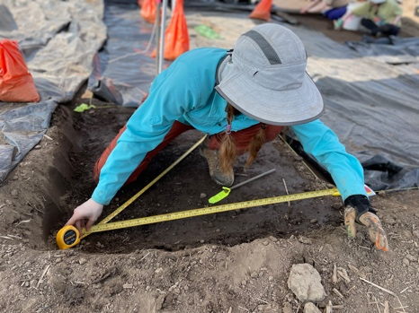
During my time at the field school, I had the opportunity to learn proper techniques for laying out an archaeological site (Figure 1). One of the fundamental methods I acquired was the application of the Pythagorean theorem to establish a perfectly square grid. This mathematical approach ensured that our excavation areas were consistent and evenly spaced, enhancing the reliability of our findings. Using this theorem, we could precisely measure and mark out the corners of our excavation units. To demarcate the boundaries of each unit, I learned how to use pins and twine to create a clear and defined border for excavation (Figure 2). By hammering nails at strategic points and connecting them with twine, we established a framework that guided our excavation efforts and could be layout out on both a physical and digital map.

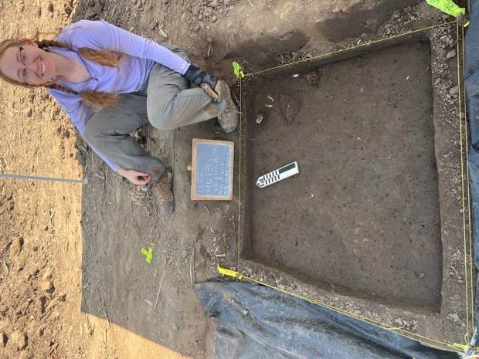
Furthermore, I gained valuable experience in labeling each excavation feature/structure. This labeling system helped us differentiate and keep track of various sections of the site, streamlining our data collection and organization processes(Figure 3).

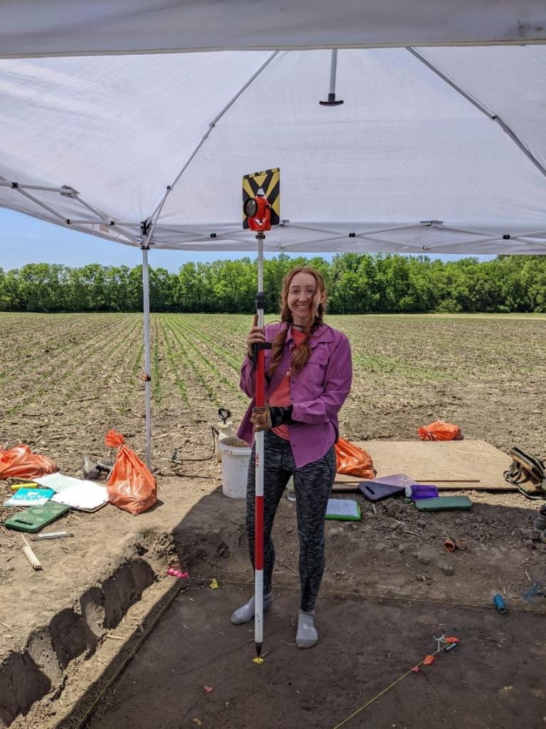
A particularly noteworthy aspect of this experience was learning how to integrate the nailed points into Geographic Information Systems (GIS). This technology enabled us to record the precise coordinates of each excavation unit, facilitating the creation of detailed site maps and aiding in the overall analysis of the archaeological landscape(Figure 4). These skills not only enhanced my understanding of archaeological fieldwork but also underscored the importance of planning and documentation.

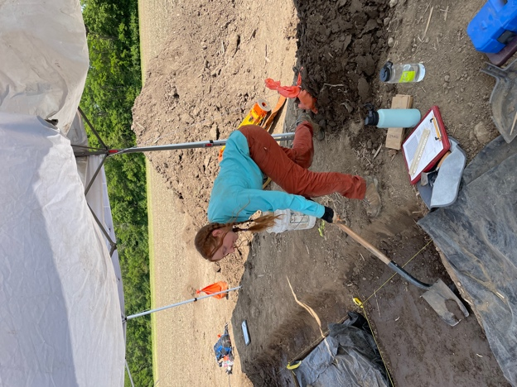
During my time at the field school, I had the privilege of acquiring essential excavation techniques that are fundamental to the practice of archaeology. One of the key skills I learned was the art of shovel scraping (Figure 5) in precise increments. This approach ensured that we could uncover archaeological features and artifacts with care and accuracy, minimizing the risk of damage to delicate materials or the accidental loss of crucial information.

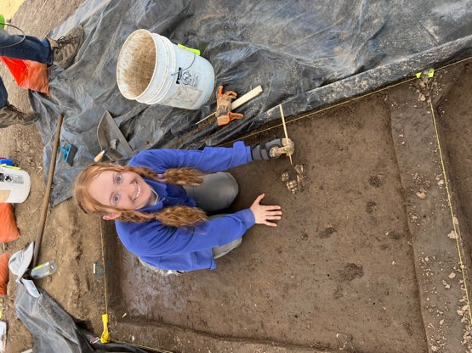
Additionally, I gained valuable insights into the use of specialized tools for delicate excavation tasks. For smaller features and artifacts, I learned to employ a trowel or even a porcupine quill, depending on the composition and fragility of the objects (Figure 6). This level of attention to detail was essential in preserving the integrity of the archaeological record, as it allowed us to uncover and document these items with precision and care. The hands-on experience I gained during this field school has been invaluable, equipping me with the skills and knowledge needed.

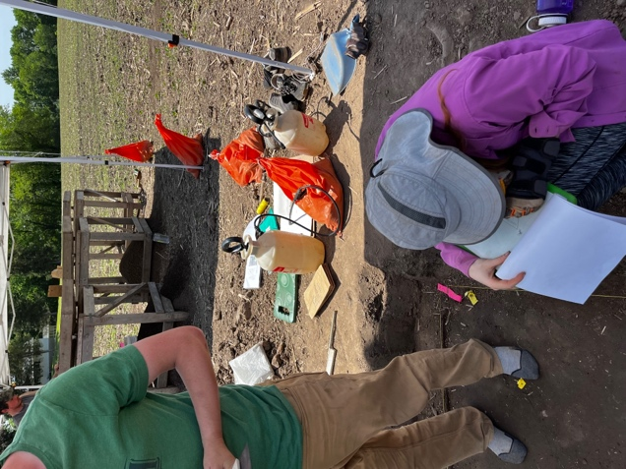
At the field school, I not only honed my excavation skills but also acquired a comprehensive understanding of how to effectively map archaeological features (Figure 7). Mapping features accurately is a critical aspect of archaeological research, and this experience proved to be invaluable. I learned how to use a grid system and establish precise points of reference to document the location, orientation, and dimensions of archaeological features within the excavation area. This methodical approach ensured that our mapping was consistent and reliable, allowing us to create accurate site plans.
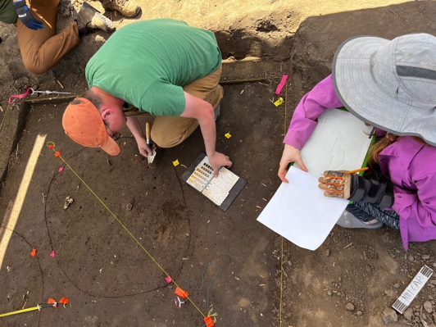
In addition to mapping, I also gained proficiency in correctly filling out fieldwork paperwork (Figure 8). Proper documentation is essential in archaeology. I was taught how to complete field forms, detailing crucial information such as the date, location, context, and description of each excavation unit, feature, or artifact. This meticulous record-keeping not only preserves the integrity of the archaeological data but also facilitates further analysis and interpretation. Learning these skills was an essential part of my archaeological education, as it emphasized the importance of precision, attention to detail, and proper documentation in the field.

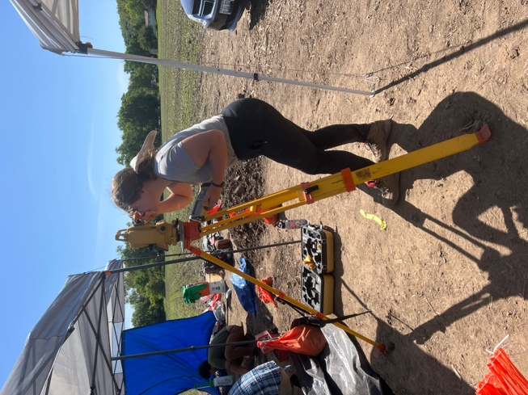
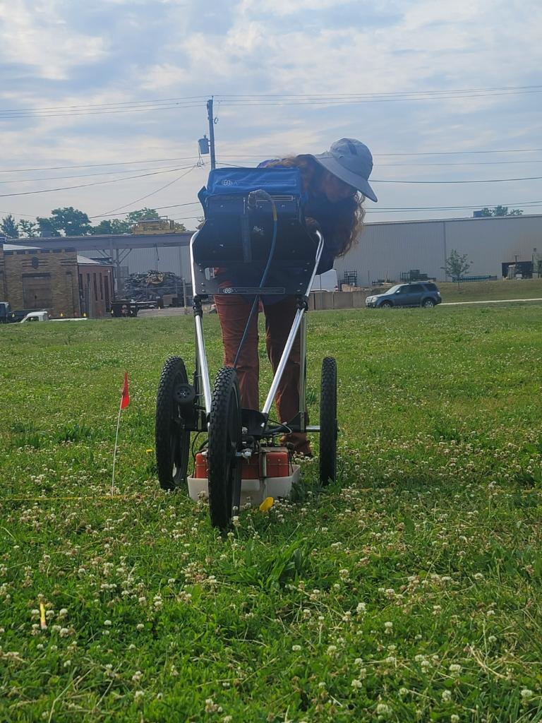
During my time at the field school, I had the opportunity to engage in two distinct yet equally valuable experiences. Firstly, I conducted ground-penetrating radar (GPR) surveys on two separate archaeological sites, which introduced me to the world of non-invasive geophysical techniques (Figure 9). Using GPR, I worked alongside experienced archaeologists to scan the subsurface layers, revealing potential archaeological features that might otherwise remain concealed. This technology provided us with insights into the composition of the sites and allowed us to identify areas of interest for further investigation. Additionally, I had the chance to apply Geographic Information System (GIS) tools in a separate endeavor. This involved inputting feature points generated from archaeological fieldwork into a device, allowing the team to then create detailed spatial maps of the identified features (Figure 10 Graduate student and skilled archaeologist Bailey Raab setting up the device). This process aided in visualizing the layout of the archaeological sites and facilitated the organization and interpretation of the collected data. Both experiences expanded my archaeological skill set and underscored the importance of embracing technology to enhance our understanding of the past, albeit in two distinct and equally enlightening contexts.

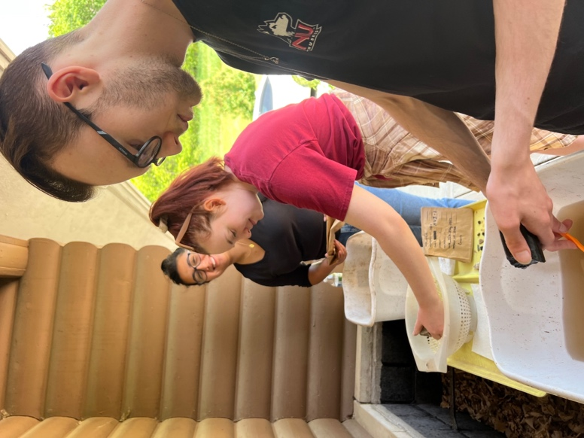
During my time at the field school, I had the opportunity to engage in valuable hands-on lab work, where I organized, cleaned, and categorized lithic, faunal, and ceramic materials. This task not only sharpened my organizational skills but also provided me with a deeper understanding of the meticulous nature of archaeological research. In the lab, I meticulously sorted and cleaned artifacts, paying close attention to detail in order to preserve their integrity. Categorizing these materials allowed me to observe patterns and trends in the archaeological record, contributing to our broader understanding of the site's history. This experience highlighted the importance of precision and patience in archaeological analysis, and it reinforced my commitment to the field of archaeology as I continue my academic journey (figure 11 fellow students prepping the materials).

Engaging in lab work at the field school not only allowed me to work directly with archaeological materials but also provided me with essential knowledge about the tools and equipment necessary for such tasks. I quickly learned the importance of using small brushes to delicately remove dirt and debris from artifacts, ensuring their preservation and accuracy in subsequent analysis. Additionally, I became familiar with the use of labeled bags or containers to securely store and transport the categorized materials.

One invaluable lesson I gained during this experience was the significance of maintaining a meticulously organized list or inventory. This list served as a vital reference, aiding in the tracking and identification of each artifact, thereby preventing any confusion or loss of valuable information. These tools and practices not only facilitated the efficient execution of my lab work but also underscored the significance of precision, organization, and attention to detail in the field of archaeology. This newfound knowledge has significantly enriched my archaeological skills and deepened my appreciation for the meticulous work that goes into understanding our past through material culture.
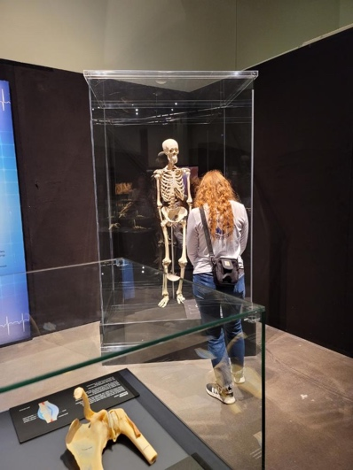
In addition to the hands-on fieldwork and practical skills I gained at the field school, I had the privilege of attending presentations by accomplished archaeologists and visiting related museums. These opportunities allowed me to broaden my understanding of the field and gain insights into the diverse aspects of archaeology. Listening to expert speakers share their research findings, excavation experiences, and insights into various archaeological topics was incredibly enriching.

The museum (figure 12 -plaster model of bones at museum) visits served as a complementary aspect of my archaeological education, offering valuable exposure to the broader archaeological community and the significance of sharing knowledge and discoveries with the public.

In summary, my time at the field school was a transformative and enriching experience that equipped me with a diverse skill set, ranging from excavation techniques and geophysical surveying to data analysis and exposure to the wider archaeological community. The opportunity to learn from seasoned archaeologists was invaluable in broadening my horizons within the discipline. I am profoundly grateful for the scholarship that made all of this possible, as it not only deepened my passion for archaeology but also provided me with the knowledge and experiences that will undoubtedly shape my future in this field. These opportunities have been instrumental in my academic and professional journey, and I am eager to continue contributing to the fascinating world of archaeology with a profound sense of gratitude and dedication.

