Through the assistance of the Archaeological Institute of America’s Jane C. Waldbaum Scholarship I had the incredible opportunity of attending a field school in Israel at the archeological site known as Hippos (by locals known as Sussita) this summer. This Hellenistic to Islamic period site is located directly above the Sea of Galilee to the east. The earliest knowledge of this archaeological site dates back to 1883 by Gottieb Schumacher. The Israeli army created a military post in the 1950s, and shortly after the site was declared a National Nature Reserve. Excavation projects started in 1999, and research has been ongoing to present.
I chose this field school due to my interest in Biblical Archaeology. Having done some research of the field school, I quickly learned that one of the 3rd century churches that were uncovered had a mosaic depicting the 2 loaves and 5 fish biblical story of Jesus feeding the multitudes. This phenomena also took place on the Sea of Galilee, on the northern side of the sea. The price of the field school would have set my back plenty, had it not been for the generous field school scholarship that I was awarded. This was not only my first field school ever, but my first time traveling abroad to a biblical archaeological site.
Since this excavation has been ongoing for over 20 years, the researchers tend to pick up where they left off from previous field seasons. Our field school’s work schedule started at 4:45 AM, which is when out charted bus picked us up. The drive from the bottom to the top of the mountain, took about 10 minutes. The road involved many switchbacks. Due to the early start, we always caught the sunrise shortly after arriving on site. Our drop off point is at the start of the Hippos Sussita National Park. We then would have to trek on foot about a mile to get to our dig location. This walk was fascinating, because we walk through modern day cemented stairs that eventually are matched to the original Roman road. The rest of the path is about a quarter mile walking through the Decapolis city.
During my first day, we quickly were divided into groups and sections of a Byzantine home that we were to excavate. Due to budgeting, the archaeological staff shoveled all the topsoil which took nearly two weeks until we started getting to archaeological strata. However, it would be in this topsoil that I uncovered a Roman coin! Some other finds of the season were mosaic floor, a water basin, a cistern, and many artifacts. An interesting artifact relocated was a glass piece of a chandelier. It was hard to imagine how this piece fits into the whole, and what this glass chandelier would look like. Serendipitously, during one of my weekends off I went to Petra. At the Petra museum, they have one of these type of glass chandeliers on display. I was thankful for this to come full circle and to make that connection.
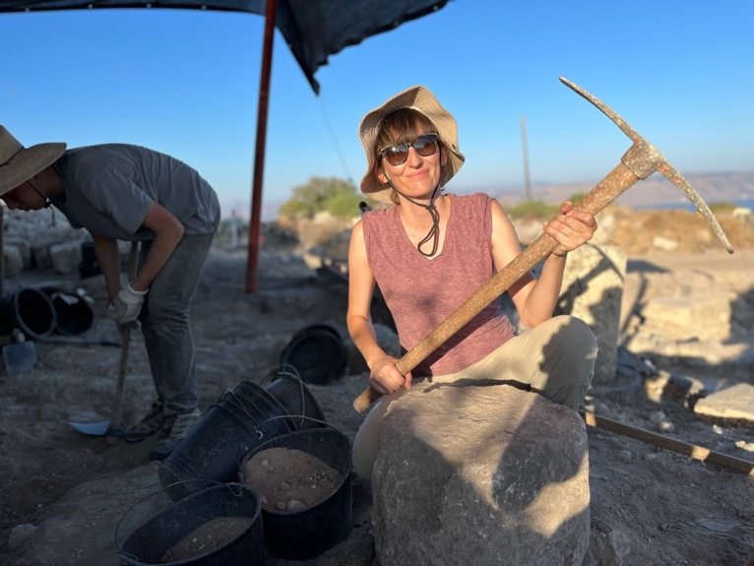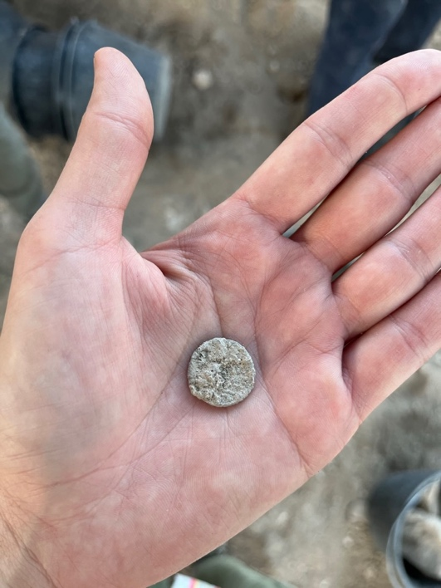
Left: Photo of the author digging inside a Byzantine period home.
Right: Photo of the Roman coin that I dug up out of the topsoil.
Aside from in the field excavation experience, use of total station, artifact collection, identification, we also learned GIS and photogrammetry. Each week we had a scheduled field trip to an archaeological site in the area. These visits were classical period, and historical period places. We also had an instructional presentation each week given by one of the crew archaeologists. One of my favorite tasks was working with the Head of Conservation, Yana Qedem. She is the conservator for the mosaic floors found at the site. I learned how to carefully clean the tesserae, so that we were able to read the Greek written font and see the depicted images in the flooring. Another highlight was when I helped uncovered a mosaic floor that hasn’t been seen for over 1,500 years! Though the written message and imagery has been deciphered, since it yet to be published I have to refrain from further discussion of it.
Lastly, I want to express my gratitude for the Jane C. Waldbaum Scholarship. It has tremendously help offset the costs of such an enriching experience. I would not be able to fulfill this goal had it not been for it. This also solidified my future direction in archaeology once I graduate from my program.

