Receiving the Jane C. Waldbaum Field School Scholarship granted me the opportunity to attend the Aditu Arkeologia Field School in Roncesvalles, Spain. With the funds, I was able to pay a portion of the tuition for the field school. In the effort to pursue my osteological knowledge, I spent a whole month at the site in Roncesvalles. This site is unique because of the vast amount of human remains and the significance of the Battle of Roncesvalles in 778 AD.
The Aditu Archaeological Field School is a research project that started in 2019, located in Roncesvalles (Northern Navarre, Spain), where they are investigating the origins of the medieval ossuary, Silo de Carlomagno. The ossuary is rumored to be the burial site of the rearguard of Charlemagne’s army, that was ambushed in the Battle of Roncesvalles. And this town is also historically significant for it is a resting stop for pilgrims hiking, el Camino de Santiago. Roncesvalles is a town that holds history within its old stone architecture and religious relics. Which is why I choose to attend this field school.
Since I stayed for a month in Roncesvalles, I was able to participate as a student and be a part of the team during the two sessions of the field school. I came to this field school with a reasonable background in osteology, so I had a quickness when identifying human remains but a challenge since the remains were corroded at times. This was also my first field school and any kind of field work. A day at Roncesvalles consisted of lectures in the morning over zooarchaeology, field methods, Basque archaeology, history of the Battle of Roncesvalles, biological profile of human remains, osteology, pathology, and trauma, and excavating human remains. Each of the lectures tied into the work we were doing and a general understanding of the site. After lectures, the rest of the day consisted of field work at the Ossuary and sorting the human remains. Field work was very complex since every step you took, you were on a human bone. On the field, we were put into groups where a couple of groups sorted through the excavated remains and two groups were excavating at the site below. The excavation process was something unfamiliar for me since it was my first time, and the vast amount of human remains at the site was overwhelming. The director would assign us to an area, and we would dig until we found an articulated skeleton or an artifact of value. After a couple of days, excavating and sorting human remains became less tedious and more fascinating. The sorting was a continuous task that I enjoyed because I was challenging myself to identify the remains and recognizing human variation from the bones. Aditu had a method of sorting the human remains based on what bone it was (i.e., radius, patella, etc.), if it was left or right, and how complete or incomplete it was. This was helpful to figure out a minimum number of individuals in the Silo. Although there was a vast amount of commingled remains, the chance of finding an individual buried at the Silo was not rare. An individual burial was the best part of the excavation process because of the diligent process of uncovering and identifying them. Overall, this field school showed me the ropes in excavating human remains and being able to identify each bone.
When I was not on the field, I enjoyed hiking around the area and walking over to the next town to collect snacks. I also celebrated my birthday and took a short trip to Donostia-San Sebastian to explore more of the Basque country. And had a surprise guest from the King and Queen of Spain visiting the Ossuary. This was a very special trip for me since I was solo traveling, which was a challenge, but I feel very confident in identifying and siding bones. In the end, I acquired the skills and mastery of archaeology and osteology that I can apply soon.
I am immensely grateful for the chance to have attended this field school and for the Archaeological Institute of America for choosing me as a candidate for this scholarship. Attending this field school not only expanded my knowledge in human osteology but also introduced me to the amazing team at Aditu and meeting other students who had the same interest as me. I wanted to give a special thanks to Laurel Sparks for helping me in the process of applying and receiving the award. Also thank you to the team at Aditu for teaching me all there is to know about bones, archaeology, and the Basque Country. The time I spent in Roncesvalles was a golden opportunity I will never forget.
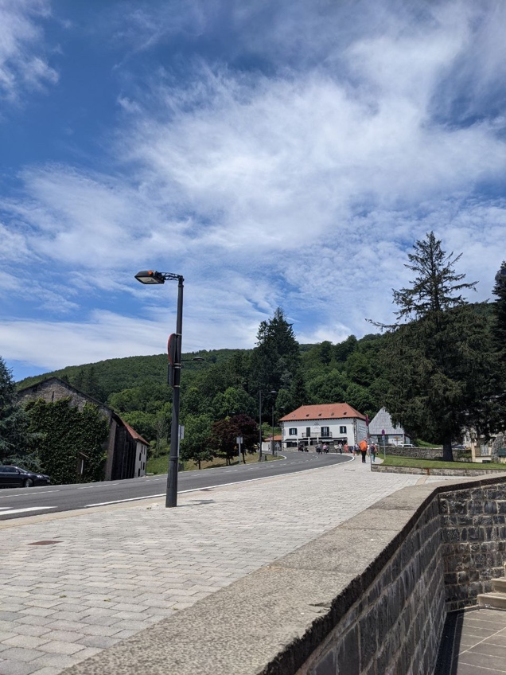
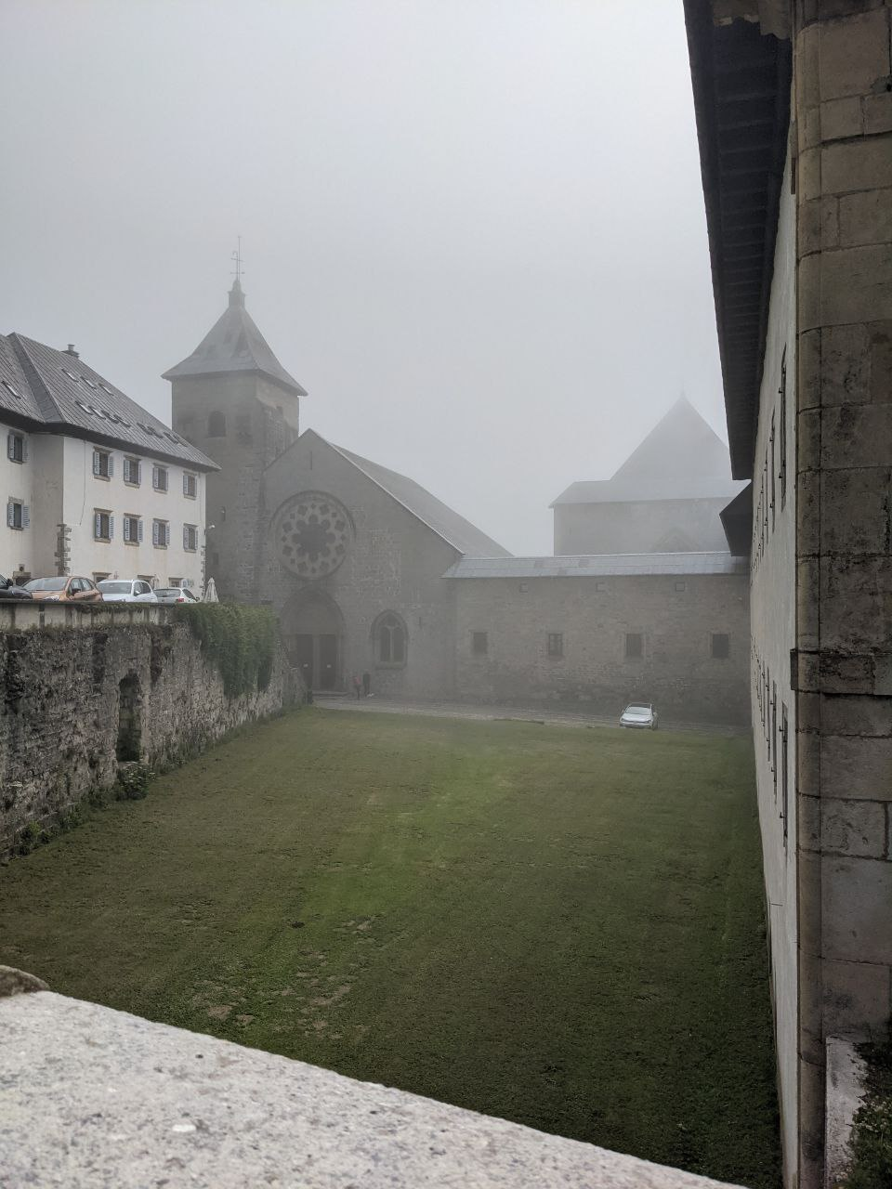
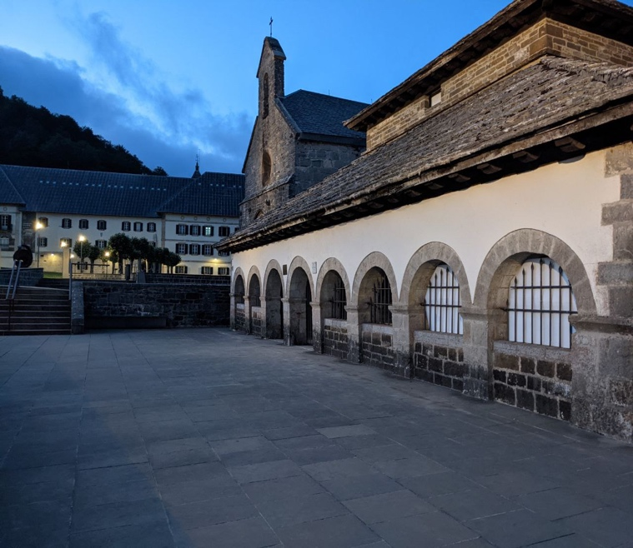

Views of Roncesvalles; (top right) The small village of Roncesvalles. (top left) Pictured is the Real Colegiata de Santa Maria (catholic church). (Bottom left) the Silo de Carlomagno (the ossuary).

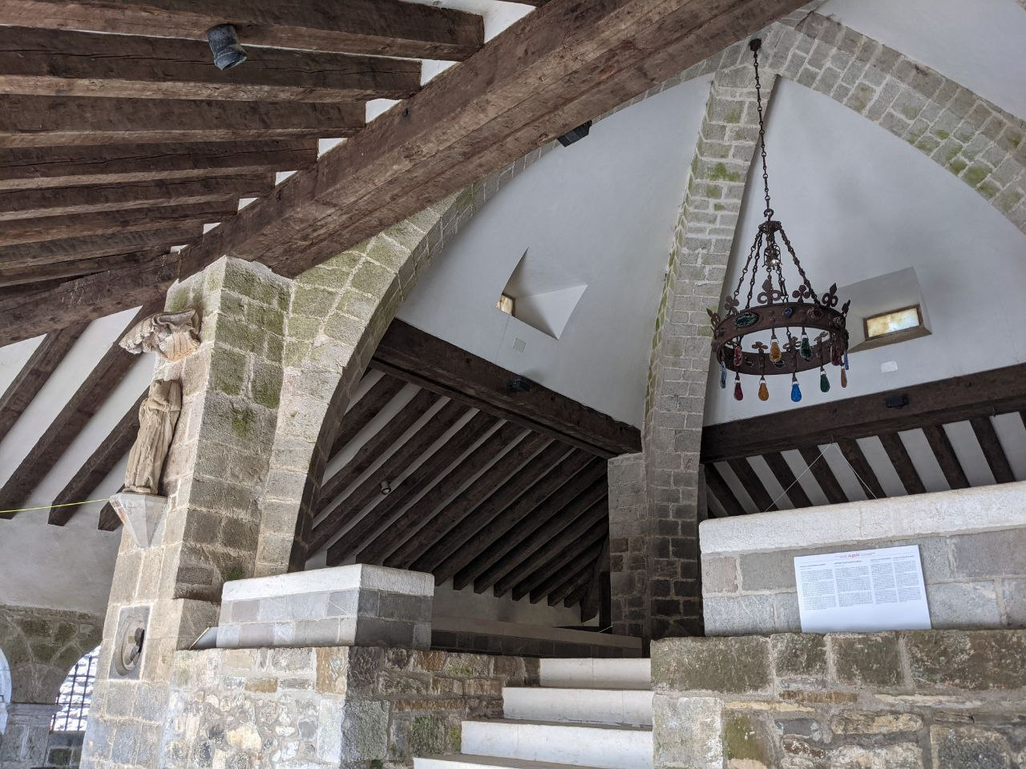

Inside the Silo de Carlomagno. In the middle of the Ossuary is an altar and around are modern burials, usually locals or pilgrims.

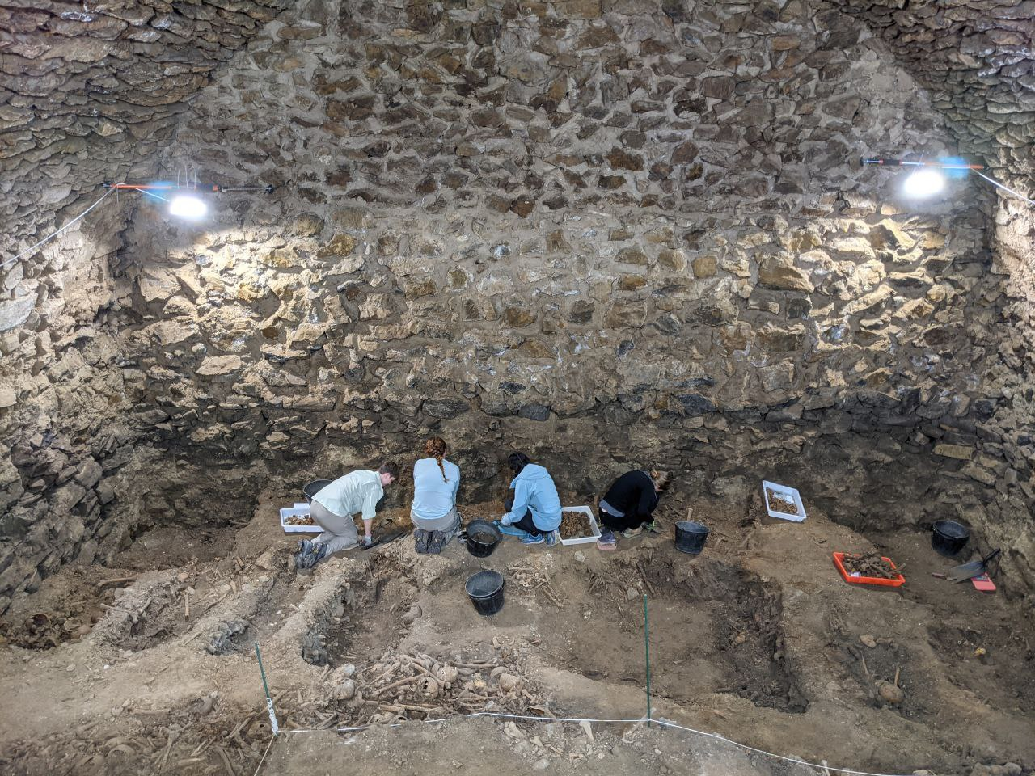

The pit of the ossuary. This is below the ground and above (not pictured) is a square opening to the ground level of the ossuary. This is possible a “dumping” area to dispose of the non-living.

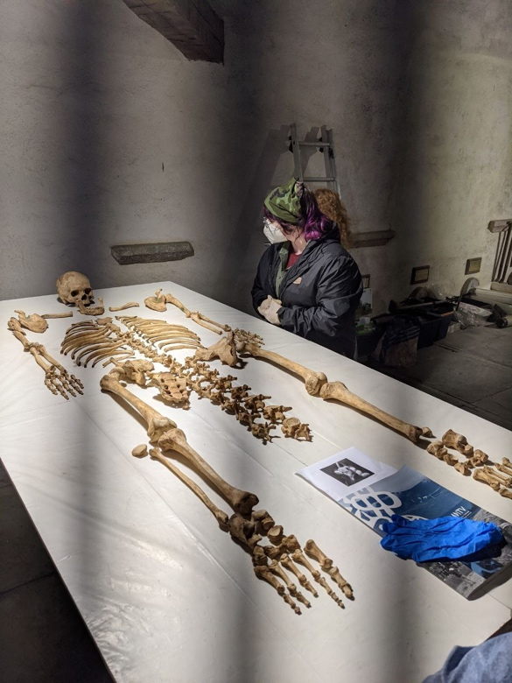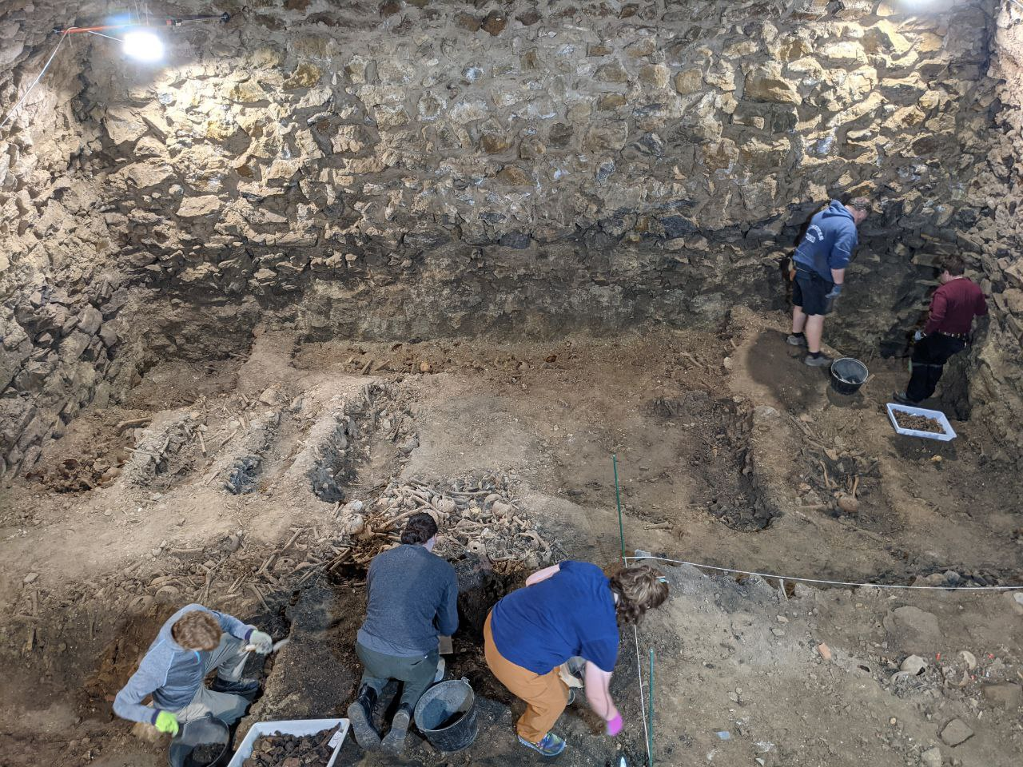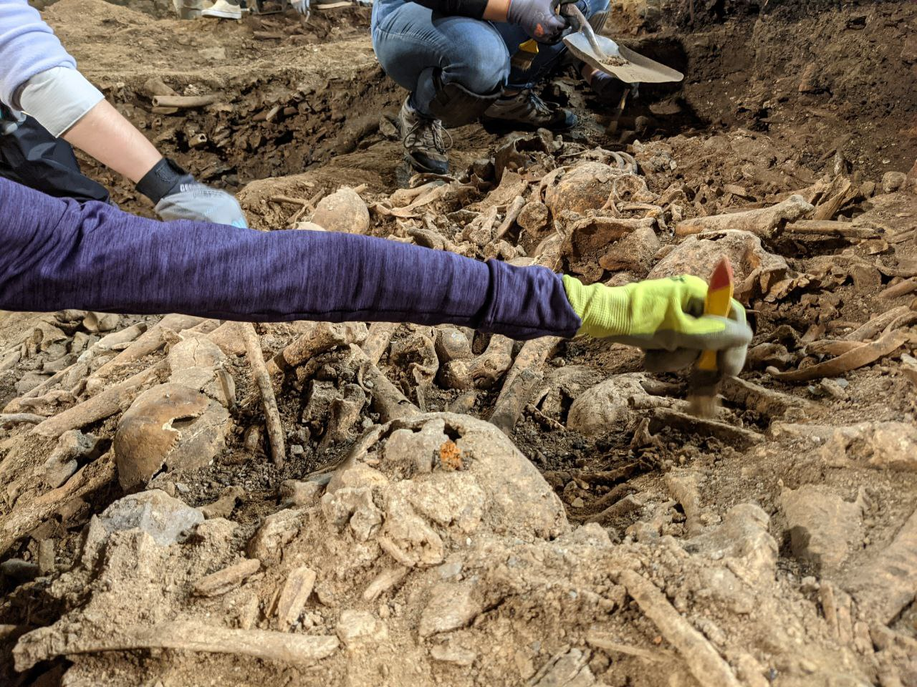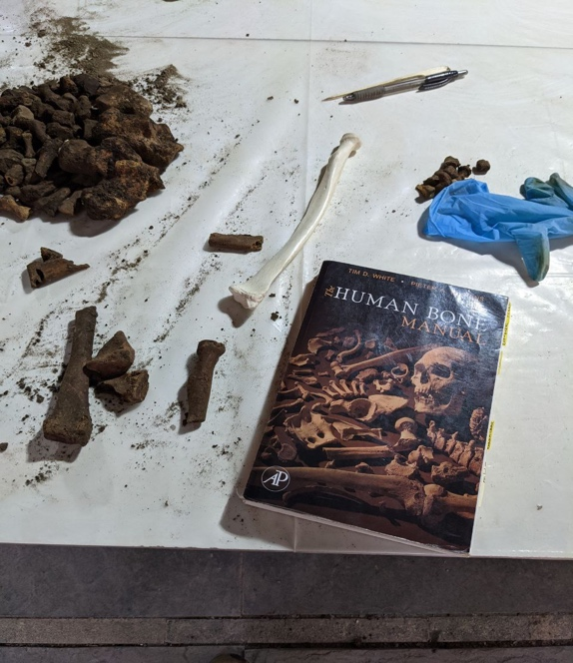

These photos show a typical day on the field. (Top left) An individual is laid out in anatomical position to be inventoried, analyzed, and identified. (Top right) My last photo of the field; the pits are from individual burials. (Bottom left) Photo from first day on the field; my team worked on uncovering a mass burial in the middle of the ossuary; possible French soldiers from the battle in 778 AD. (Bottom right) After sorting through excavated human remains, I was working on siding the radius for inventory.

