Final Report

My four weeks spent excavating as part of the Lechaion Harbor Settlement and Land project were some of the most transformative weeks in my life. During my time on the project, I not only learned how to excavate properly, but how to collaborate with others and form lasting friendships. I am forever grateful that I was selected for the Waldbaum Scholarship, as without it I would not have been able to participate in this lifechanging experience. The field school at Lechaio not only provided essential hands-on education in the field of archaeology, but also toured us around Greece, giving us behind the scenes tours at sites such as Mycenae and Nemea and showing us the best places to get gelato in Nafplio. Every moment of this experience felt magical to me, and only further ignited my passion for Classical archaeology. I am truly grateful to the donors of the Waldbaum Scholarship for providing me with this opportunity!

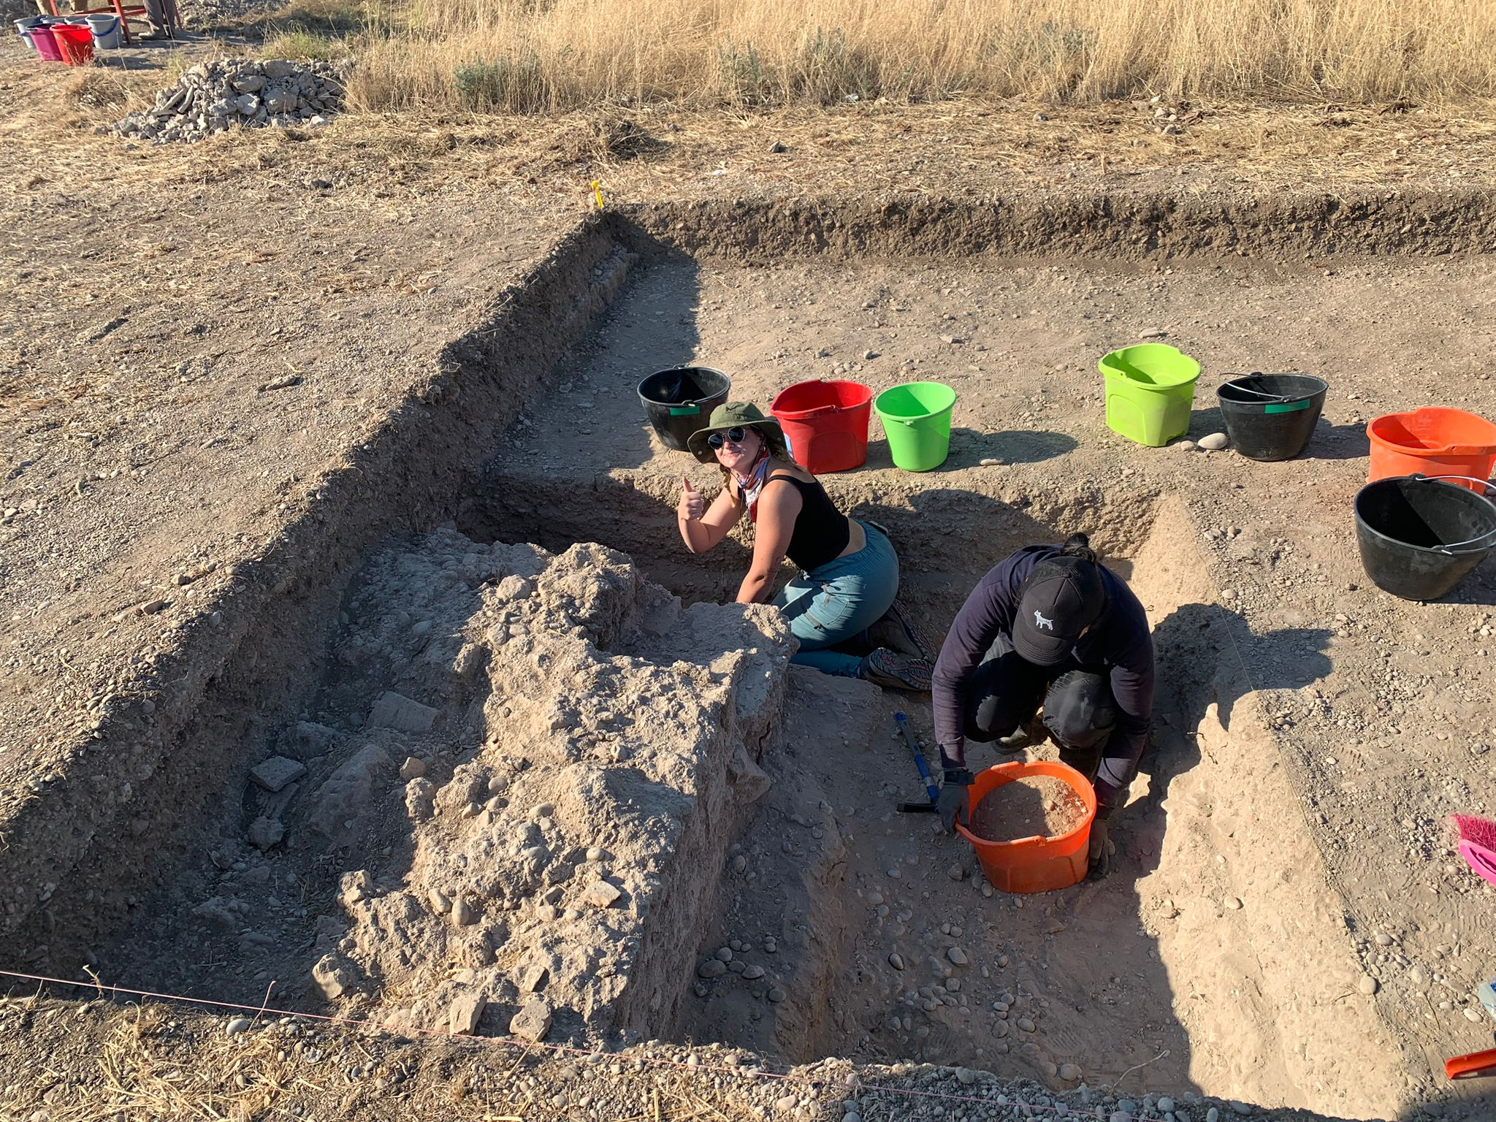
Caption: In my trench, taking a break from sweeping dirt into a bucket to give a thumbs up. Lechaio, Greece

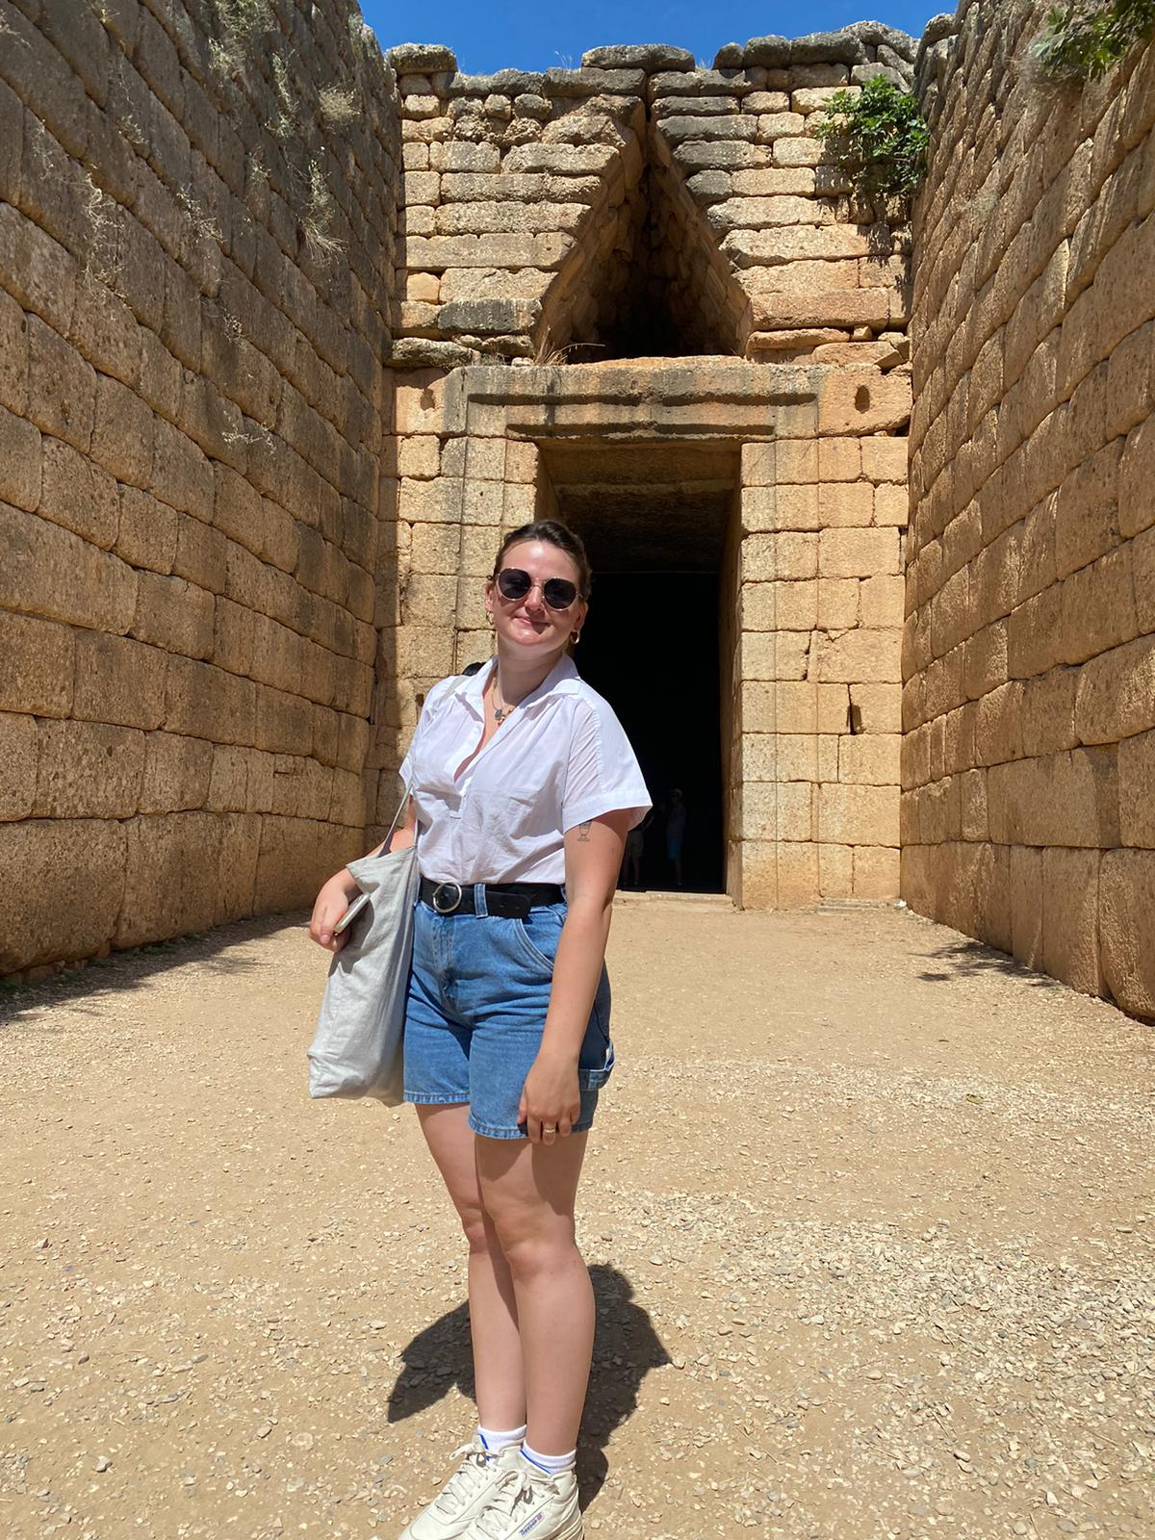
Caption: At the Treasury of Atreus in Mycenae

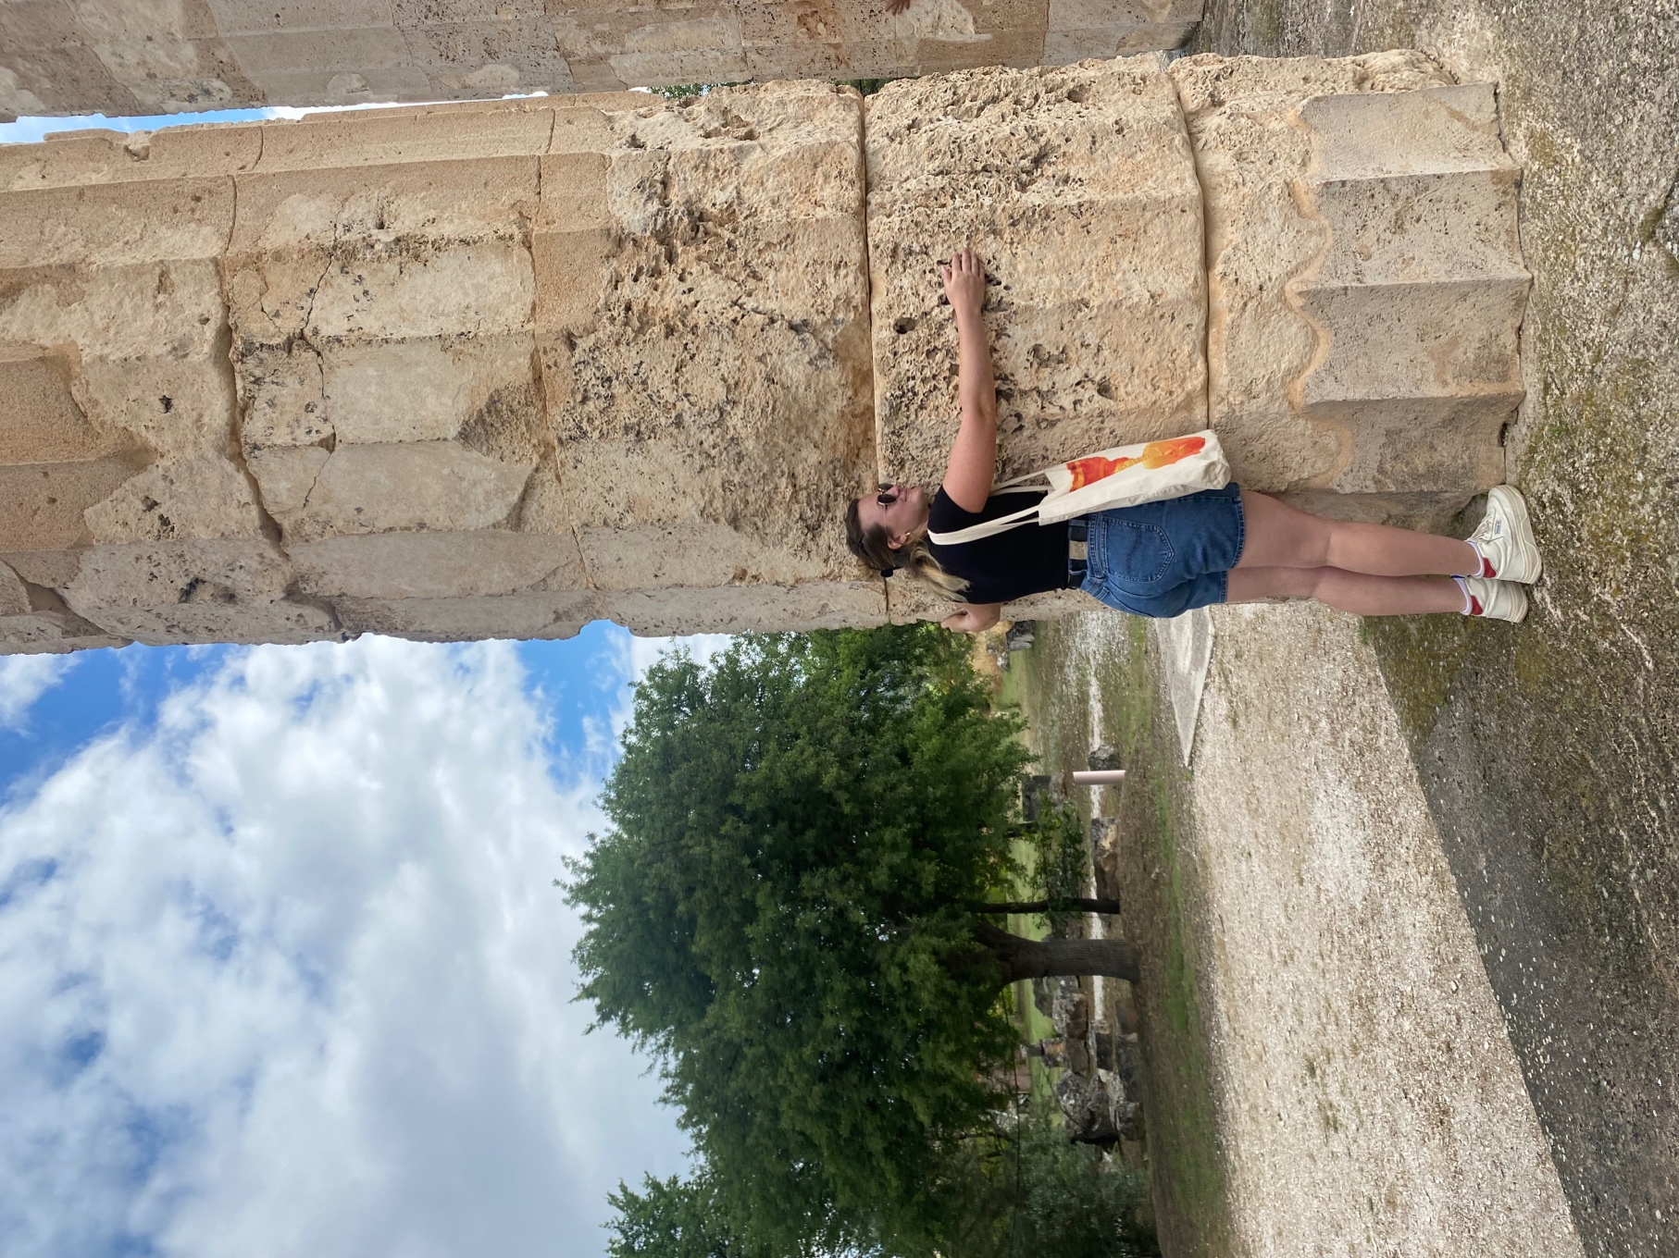
Caption: Hugging a column at Nemea

