NEW STUDY ABROAD - SUMMER 2023 IN ISRAEL
Caesarea Coastal Archaeological Project (C-CAP)
June 27-July 26, 2023
Prof. Asa Eger (Department of History, UNCG)
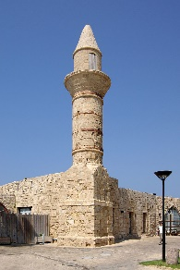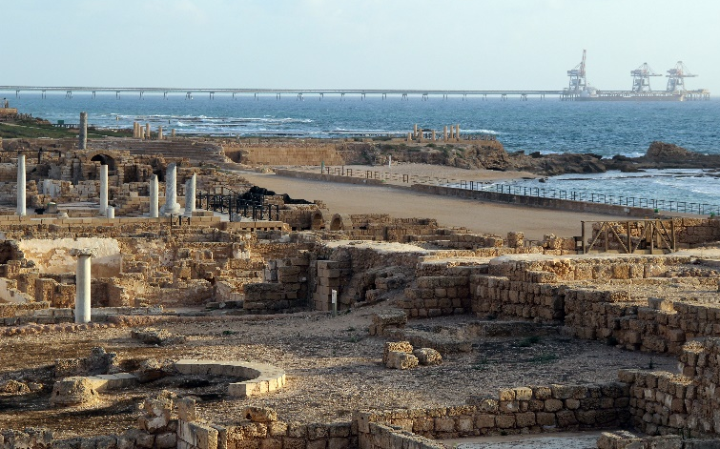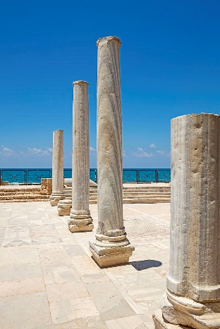
- Participate in an archaeological field school, learn the fundamentals of excavation methods. No prior experience in archaeology is necessary.
- Learn the history of the largest site in Israel from the Hellenistic to Ottoman periods. Caesarea Maritima was once the capital of Roman/Byzantine Palestine.
- 6 credits in 2 courses (HIS 390: History Internship and HIS 478: Research Methods in Historical Archaeology or HIS 690 twice) on the archaeology, history, and environment of the city.
- Includes two day field trips to sites in Israel in the north Galilee and to Jerusalem.
- Study Abroad includes all room and board in Israel, program related travel expenses, International Programs fee, insurance, museum and archaeological site entrances for one field trips. Cost = $5,000.00, not including airfare.
- Financial Aid applicable for travel and scholarships/grants available.
- Application Deadline: December 1st – go.uncg.edu/israel
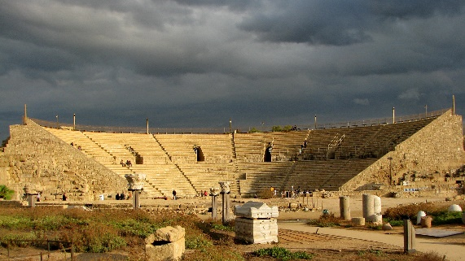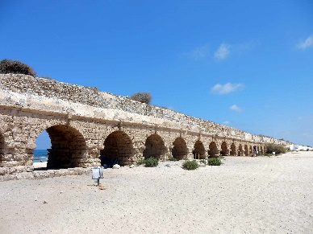
For more information please contact Prof. Asa Eger (aaeger@uncg.edu)
UNCG reserves the right to modify or to change costs in case of conditions outside of its control

